Connecticut Employment and Unemployment in the 2008-09 Recessionª
Introduction:
This report examines trends in employment and unemployment in the Connecticut economy during the 2008-recession. Employment and income statistics on key sectors of the State economy will be presented, along with analysis of the effects of anti-cyclical policy (e.g. funding from The American Recovery and Reinvestment Act). Longer term State efforts at addressing regional employment issues will also be detailed. The depth and length of the current downturn is exceptional; additional interventions at the State and Federal level may be necessary to address rising unemployment. In addition, the recession has caused more severe economic problems in certain regions of the State, particularly in the largest cities. In the short-term this will require the continued expenditure of federal and state dollars to cushion the effects of the economic downturn. As it is likely that some of the regional unemployment problems may persist well beyond the end of the recession, the consideration of new growth-inducing investments may be needed.
Although the current recession officially started in the first quarter of 2008, the impact on employment in the State of Connecticut was not felt until later that year. Employment in the State peaked at 1,769,000 in April of 2008, with an unemployment rate of just 5.2%. Total employment was still slightly higher (by 200,000 jobs) in December, but the unemployment rate had risen to 6.0%. A year later, in December of 2009, total employment had fallen to 1,715,000, with 167,900 persons unemployed (a rate of 8.9%). Although the unemployment rate for the State is significantly less than for the nation as a whole, it still represents a considerable deterioration in labor market conditions. Job losses (December on December) have been particularly severe in the construction industry, with a 12.3% decline, and in manufacturing, with a 8.5% decline. The Administrative and Support services sector has also experienced a significant weakening (8.6% drop in employment).
The Recession’s Impact on Key Sectors of the Connecticut Economy:
This section will examine changes in employment and unemployment in key sectors of the Connecticut economy, notably construction, education, health care and financial services. Manufacturing employment will also be examined, particularly in light of the State’s reliance on defense spending.
--------------------------------------------------------------------------------------------------------------------
ªProduced by: Maya Abinaka, Leandra Charsky, Thomas Fanning, Jeffrey Frenzilli, James Jessup, Vincent Keeney, Alanna Locast, Gregory Lynch, Emily Mandler, Melissa Martinez, Timothy McCabe, Matthew McIntosh, Megan McLaughlin, David Nevins, Geoffrey Orth, Andrew Palazzi, Joseph Purtill, Patrick Shanley, Anne Skorupski, Matthew Sullivan, John Tessitore, Nicolas Tomboulides, Thomas Trapani, Kenneth Vigilo, Marit Westenberg
Construction:
The Construction Sector of Connecticut is comprised of organizations that are engaged in construction of buildings or other projects, including utility systems and infrastructure. This sector of the state had seen very steady employment over the past 10 years, which could be attributed to the strong housing industry pre-2007. Currently, the 52,400 workers employed in the construction industry make up only 3.4% of the total persons employed in the state of Connecticut. At its peak, the construction industry was employing about 69,100 people in the state. Employment in this sector has dropped a total of 27% since the sector began to shed jobs from its peak in October of 2007. This 27% decrease in construction employment is equal to 18,900 jobs in the state of Connecticut.
In the first quarter of 2009, the Hartford Labor Market Area employed the largest amount of construction laborers in the state, around 19,230. The labor market employed more than 37% of all construction oriented laborers in the state. The median wage of construction workers in this labor market is approximately $23.88 per hour, leading to a yearly wage of approximately $49,670. Good paying jobs such as these are essential to the economy of the Hartford area.
The Bridgeport-Stamford Labor market employed the second highest number of construction laborers in the state. 12,710 persons were employed in the first quarter of 2009 in this area, which made up nearly 25% of the state’s construction employment. Workers in this area were paid an average of $.79 less per hour than workers in the Hartford Labor Market Area, leading to a median wage of $23.09. Their yearly median wage was roughly $48,000.
The New Haven Labor Market Area employed 10,190 workers in the first quarter of 2009, accounting for approximately 20% of the construction workers in the state. Construction laborers in the New Haven Labor Market Area are the highest paid in the state, earning a median hourly wage of $24.28, or a yearly wage of approximately $50,509.
2,720 persons were employed in the construction industry in the Danbury Labor Market Area, making up only 5% of the total persons employed in this region of the state. Workers in this area were some of the lowest paid in the state, earning an average of $22.26 per hour, nearly $2.02 less per hour than those employed in the New Haven Market Area. Workers earned a median yearly wage of $46,290 in this area.
The Norwich-New London Labor Market Area saw an employment of 4,670 workers in the first quarter of 2009. On average, workers were paid $22.24 leading to an annual income of $46,270. Construction employment in this labor market area made up for 9% of construction employment in the state.
Construction occupations in the Waterbury Labor Market Area earned the lowest median wages of any workers in the same industry in the state. Workers were paid on average $22.01 per hour, and an annual wage of $45,784. These workers on average were paid $2.27 less per hour and $4,725 less per year compared to workers in the same industry in the New Haven labor market area.

LMA | Employment-Construction | Median Wage ($/Hour) | Median Wage ($/Year) | % of construction workers in state
Hartford | 19230 | 23.88 | 49670 | 37.10
Bridgeport-Stamford | 12710 | 23.09 | 48030 | 24.52
New Haven | 10190 | 24.28 | 50509 | 19.66
Danbury | 2720 | 22.26 | 46290 | 5.25
Norwich-New London | 4670 | 22.24 | 46270 | 9.01
Waterbury | 2310 | 22.01 | 45784 | 4.46

The sub-category of Specialty Trade Construction employed the largest number of construction workers in the state with 36,862 workers. Working at over 7,000 work sites across the state, these workers earned an average quarterly wage of $12,731. The next largest sub-category of workers in this industry worked on the construction of buildings. 10,850 persons worked at nearly 3,000 work sites across the state. Those employed in the category earned an average quarterly wage of $14,872. The smallest sub-category, and also the highest paid, were those employed in heavy and civil engineering construction. 4,067 workers earned an average quarterly income of $17,324.
Even though the construction industry has posted the largest percentage of job loss of any sector in Connecticut’s economy, the sector may be reaching a bottom. July 2009 saw the lowest construction employment the state has seen since the late 90’s, but employment has been on the rise since then. In September 2009, 51,800 people were employed in this sector.
In October 2009, it was reported that 52,400 jobs in Connecticut were in the construction industry. This industry was tied for first when it came to job gain percentage between October 2009 and September 2009. Though the gain may have been meager, only 1.2%, any gains are more than welcome considering the losses that have occurred over the course of the past couple of years. In addition to this, economically depressed areas are looking towards development of brown fields and other areas to promote fiscal growth. The construction sector will play a pivotal role in the creation of centers for economic growth.
Healthcare
The Healthcare Industry is one of the few employment sectors that has fared relatively well during the current Recession. Historically the industry, like education, has been a relatively recession-proof industry due to the inelastic nature of health care demand. In most cases, if a person needs medical attention they cannot wait for it to become more affordable, or for their medical insurance to be restored so they must find a way to pay for it. However, in the long term hospitals and physicians do face the danger of patients forgoing regular checkups, skipping prescription refills, and waiting to perform nonessential medical treatments.
These economic conditions will lead to decreases in revenue for hospitals and private practices, which will most likely result in layoffs, mergers, and acquisitions. Layoffs throughout the state in other industries have affected patients’/clients’ insurance benefits and coverage. Despite this, the health care industry has steadily grown over the past decade. The following chart shows the slow but steady increase in average yearly salary and employment numbers for the health care industry in Connecticut. These numbers include employment in hospitals, ambulatory health care services, and nursing and residential care facilities.

The strength of the health care industry over the past ten years distinguishes it as a slow but steady growth industry. It has not been characterized by rapid spikes in growth or rapid patterns of decline. Healthcare is also one of the higher paid industries in the state. The five highest paying occupations in the healthcare profession are surgeons, OBGYNS, general internists, psychiatrist, and physicians. All of these professions have annual salaries of well over $150,000.

Connecticut currently employs 226,800 people in the healthcare sector with an average annual salary of $54,300. The following chart breaks down earnings in the health care industry even further by dividing workers into Healthcare Practitioners and Technical Occupations and Healthcare Support Operation.

The impact of the health care industry on the state of Connecticut’s economy is significant. Of the top 20 employers in the state, five are part of the health care industry: Hartford Hospital (6,000 workers), U Conn Health (6000 workers), Yale New Haven Psychiatry & Yale New Haven Health (6000 workers), Danbury Hospital (4,000 workers), and St. Francis Medical (3000 workers). In total, 25,000, or 11% of all health care workers are employed by these major health care facilities. The size and significance of the health care industry in this state is partly a result of the aging demographics of the state.
Nationwide the employment rate is at one of the highest levels in modern history, and yet demand for certain health care industry employees is still strong. Registered Nurses are the most sought after workers, and Licensed Professional Nurses are in high demand as well. Pharmacists, and medical technicians are also in high demand. These job openings create opportunities for currently unemployed individuals to be trained to fulfill these open positions. A proportion of structural unemployment can be easily eradicated if training can be completed efficiently and newly trained individuals can be quickly matched to the openings in this field.
References:
Connecticut:
http://www.ctdol.state.ct.us/lmi/ct_healthcare_occs.pdf
http://www.ctdol.state.ct.us/lmi/industries.htm
New Jersey:
http://lwd.state.nj.us/lpaapp/app?
Massachusetts:
http://www.mass.gov/
Finance and Insurance
The insurance industry is critical to the economic well-being of the State. Historically, the city of Hartford has been dependent on the insurance sector for a significant component of total employment. Important insurance carriers, those will annual turnover of greater than $2 billion, include Hartford Financial Services Corporation, Aetna,Inc., W.R. Berkley Corporation, the Phoenix Companies, Inc., and Odyssey Re Holdings Corporation. Overall, the State reported having 17 life insurance companies, 11 accident and health insurers, 26 fire, marine and casualty insurance providers, and 8 reinsurance firms. Although the importance of this sector, in terms of contribution to state GSP and employment, has declined over the past two decades it remains critical to the economic health of the State.
The Connecticut banking industry is comprised of numerous large, out-of-state institutions, as well as a small number of largely intrastate institutions. The largest in-state institution (measured by assets) is Webster Bank, headquartered in Waterbury, followed by People’s Bank of Bridgeport. Webster’s total assets exceeded $17.8 billion in 2008, while People’s assets were just over $11 billion. None of these institutions is a significant force in cross-state banking, but all contribute significantly to the sector within Connecticut
Connecticut Department of Labor statistics demonstrate both the importance of this sector to total state employment, and the stress that this sector has been under during the recent downturn. In December of 2008, over 121,000 persons were employed in the finance and insurance sector, approximately 7.3% of total state employment. By December of 2009, employment had fallen to 118,000 (still essentially 7.3% of a now diminished active labor force). Average weekly hours per employee have not been suppressed, however, rising from 35.6/ week in December of 2008 to 36.9 hours/week in November of 2009 (the last month for which data is available). Average weekly wages were $1536.9 in November of 2009, an increase over prior monthly observations (monthly wages vary widely, increasing, for instance, during income tax season). This can be compared to an overall average weekly wage of $935/week for all private workers in the State. The increase in weekly hours suggests there may be some pent-up demand for additional employees as the recession eases.
The Manufacturing Sector
Like most northeastern states, manufacturing in Connecticut has been on a long slow decline since the 1980s. Employment in this component of the economy was 185,000 in December of 2008, just over 11 percent of the total labor force. The economic downturn reduced employment to just 169,000 in December 2009, a drop of 8.5%. Even with this reduction in the number of employees, the industry has experienced a drop in the average workweek, from a peak of nearly 42 hours in November 2007, to 39.9 hours in November of 2009. Average weekly earnings peaked at $1212 in June of 2008, and have since fallen to just $1165 (CT DOL). The reduction in average weekly earnings in what is one of the higher paying sectors in the State inevitably spills over into the rest of the economy.
The State remains dependent on defense spending, with many of the major manufacturing employers fortunes tied directly into the level of federal outlays. Ranked by 2006 sales, the 10 largest manufacturing firms in the State are detailed below:

Firm | Sales (2006), millions | Sector(s) | Corporate  Location
General Electric | $151,320 | Diversified manufacturing | Fairfield
United Technologies | $ 36,760 | Aerospace, defense, building materials | Hartford
International Paper | $ 25,548 | Paper, packaging | Stamford
Xerox | $ 14,788 | Copiers and Office Systems | Stamford
Gerald Metals | $ 9,300 | Non-ferrous, precious metals | Stamford
MeadWestvaco | $ 8,227 | Paper, packaging | Stamford
Praxair | $ 6,594 | Industrial Gases | Danbury
Pitney Bowes | $ 4.957 | Office machines | Norwalk
Terex | $ 3,897 | Construction Equipment | Westport
Chermtura Corporation | $ 3,700 | Specialty Chemicals | Middlebury

Although only two of these firms, General Electric and United Technologies rely heavily on defense spending, they are by far the two largest firms in the State. Federal appropriations for the acquisition of C-17 aircraft, development of the F-35 Joint Strike Fighter program, F-16 fighter jets and the Virginia Class attack submarine program directly benefit the State. Nearly $3 billion was allocated in the most recent defense budget for the acquisition of helicopters and equipment.
Education
The educational services sector acts as a stabilizer during recessions, as total employment tends not to vary as much as other sectors of the economy. In January 2007, before the onset of the recession, 19,343 persons were employed by the State of Connecticut in Educational Services. By January of 2009, that number had risen to 19,885. Annual employment in 2007 stood at 23,376 persons, rising to 24,2227 in 2008. Figures for February through May of 2009 indicate a rise in employment. Similarly, employment in private institutions averaged 49,265 in 2007, and rose to 51,348 in 2008. Preliminary figures for 2009 suggest little weakness in hiring and retention. A similar situation exists for local school districts, the largest class of employers. Employment is down slightly across comparable months between 2008 and 2009, less than one percent, with the total number of jobs near or at 100,000 on a monthly basis.
The salary in the education sector varies widely, but typically exceeds the mean for other occupations. Overall, the average annual salary was $55,840. Secondary school teachers made an average of $65,280 in 2008, while pre-school teachers averaged just $30,440. Salaries have tended to be stable, despite the downturn. The State has been able to count on this sector to dampen the impact of the recession, although localities that are now experiencing significant budgetary problems are unlikely to increase hiring in the near-term.
Salary Trends – Education and Health Services Sector (January)
Year | Average Weekly Hours | Average Weekly Earnings
2007 | 32.3 | $735.5
2008 | 31.1 | $746.4
2009 | 30.7 | $795.7

Connecticut’s Changing Labor Force
Labor Force Dynamics - Migration
As a high cost-of-living state, Connecticut has experienced significant out-migration during the last two decades. In the past two years alone, the State has lost 40,000 people. Clearly, efforts need to be made to pull residents back into the state. At present, people drawn into the State are primarily immigrants, particularly from South American and Mexico.

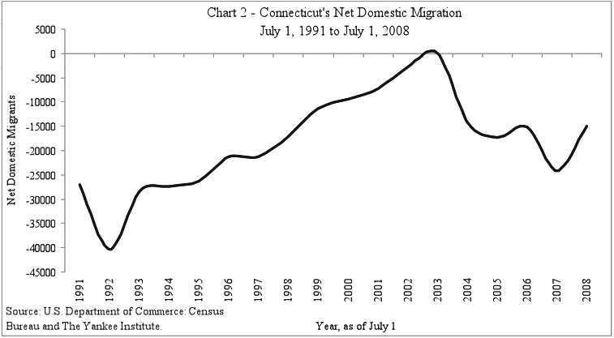

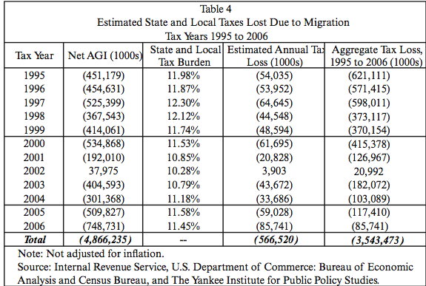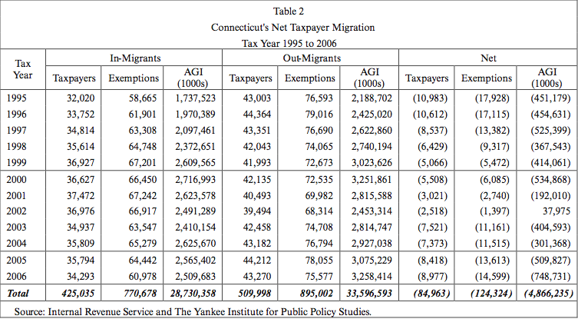
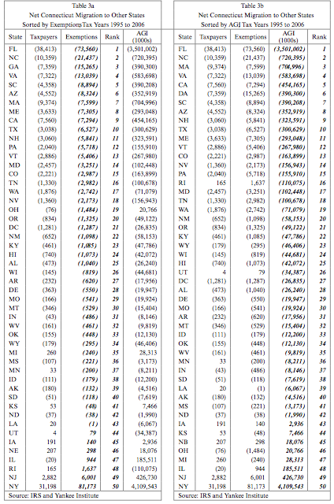
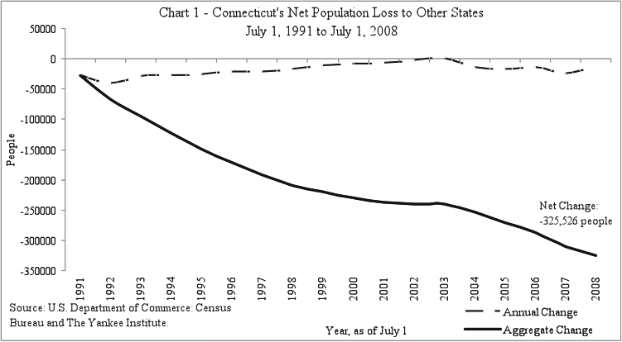

Out-Migration is a serious threat to the economy of Connecticut. The economy depends on residents as a source of tax revenue, which in turn helps to keep infrastructure, education, and other vital services running. When looking into the reasons why the citizens of Connecticut are leaving, it becomes clear that the high overall tax rates and housing prices are driving these citizens out.

Over the last twenty years, one in ten citizens of Connecticut has moved elsewhere. Also, almost half of the people who decided to stay within the state have considered leaving the state due to the high tax rates. These departures result in a reduction in effective demand, and a decision on the part of firms to slim down production and employ fewer people. An outcome of this population drop has resulted in Connecticut losing a seat in the House of Representatives, reducing the State’s ability to influence national policy.In the past twenty years, Connecticut has a net loss of over 300,000 people. The effects of this loss would be the same as if an entire small-city were to leave. Naturally, the population migrating out of Connecticut is moving towards states with lower taxes and more financially secure economies. The primary destination (see chart) for former Connecticut citizens are New York and New Jersey. Florida is a popular destination as well, because there is no income tax. Many people from the Middle-States and New England have family and friends that live in nearby states. As the population of Connecticut ages, out-migration is likely to increase, as retirees generally regard Connecticut as too expensive.
in spite of obvious out migration issues, the population of Connecticut has still been growing over the past twenty years. However, the rate of this growth has been decreasing. Between 1990 and 2000, the population increased by 118,449 people (approximately 3.6%). Between 2000 and 2008 though, the population only increased by 95,687 people (approximately 2.8%). If this trend continues at the rate it has been, this growth could turn to stagnation.

 | 2008 | 2000 | 1990
Population | 3,501,252 | 3,405,565 | 3,287,116
Source: Census Bureau
This growth in population comes from a variety of sources, such as birth rate, moving jobs, illegal immigration, and in-migration. Illegal immigration has been a major factor in demographics over the past twenty years. The top five states people move into Connecticut from are New York (81,173), New Jersey (6,001), Rhode Island (1,637), Illinois (944) and Nebraska (298).

What can Connecticut do to solve this problem?

Connecticut needs to answer the particular problems that are causing this out-migration: high taxes, high house prices, and overall living conditions. The State needs to look towards finding a reasonable way to lower the tax burden on its citizens. The decrease in income tax rates would directly feed back into the state’s economy. The lowering of income taxes would create a “domino effect”. People would take the extra savings and spend it on various goods and services, adding to the demand for different businesses, which in turn would create the need for more employees. The State would benefit from a program directed at retaining younger workers, as out-migration by this demographic, in response to the high cost of living in the State, is a significant issue.

Works Cited
Bureau, US Census. Connecticut Population Finder. 2008.
Cullen, Fergus. "Out-Migration Weakening Connecticut." Connecticut Post 8 October 2009.
J. Scott Moody, M.A., and Wendy P. Warcholik, Ph.D. "Last One Out Please Turn Off the Lights." September 2009. Yankee Institute for Public Policy. November 2009 <http://www.yankeeinstitute.org/>.

Demographics
The Connecticut labor force is significantly older than the U.S. labor force as a whole, and that trend is likely to continue into the future. Of the estimated 3,501,252 people in Connecticut 13.7 percent are over the age of 65 (senior citizens). The national average is 12.6 percent, so in accordance to the rest of the nation our state is aging (see below)
.
Connecticut:
Land area, 2000 (square miles) Conn - 4,844.80 U.S. - 3,537,438.44
Persons per square mile, 2000 Conn - 702.9 U.S. - 79.6

Info | Connecticut | U.S.
Population, 2008 estimate | 3,501,252 | 304,059,724
Population, percent change, April 1, 2000 to July 1, 2008 | 2.8% | 8.0%
Population estimates base (April 1) 2000 | 3,405,604 | 281,424,602
Persons under 5 years old, percent, 2008 | 6.0% | 6.9%
Persons under 18 years old, percent, 2008 | 23.2% | 24.3%
Persons 65 years old and over, percent, 2008 | 13.7% | 12.8%
Source http://quickfacts.census.gov/qfd/states/09000.html
Only 6 percent of Connecticut’s residents are children under the age of five, while the national average is 6.9 percent. This shows that Connecticut does not have as high birth rates as other states. The most problematic demographic is the actual change in the population from 2000 to 2008. Connecticut’s population has only grown 2.8 percent, while the national average of population change is 8 percent. Connecticut’s birth rate is only 11.9/1000 people, while neighboring states New Jersey is 13.4/1000, New York is 13.1/1000, and Massachusetts is 12.1/1000 people. This gives Connecticut one of the lowest birth rates in the northeast.
Since 1999, non-farm employment sectors in the state of Connecticut has gone from 1660.9 thousand employees, to a low (September 2009) of 1623 thousand employees. Connecticut’s strongest point of employment occurred in January of 2008 when the state had 1708.6 thousand employees. In a matter of just 20 months Connecticut lost nearly 100,000 employees, reflecting the impact of the current, very deep, recession.^{l}
Large declines in employment can be seen in the past 10 years in Trade Transportation and Utility. At the beginning of 1999 it employed 311.4 thousand people, now just ten years later it only employs 291.8 employees. The employment sector with the highest amount of workers is Education and Health Services. Health and Education employs 303.2 thousand workers, and is on the rise. In January of 1999, this sector only employed 238.4 people. This is a very good sign for the state of Connecticut. Many adults in Connecticut are going back to college because of the recession, and this will make the sector grow even more. Hopefully students looking for jobs, especially teachers will stay in Connecticut to work after they graduate because of how quickly this sector is growing, and the potential opportunities it presents. Another fast growing sector is the Leisure and Hospitality sector, since 1999 it has gained more than 30 thousand employees, and just like Health and Education, it employs the highest number of people it has in 10 years. These two sectors give Connecticut a beam of hope and it looks like more people in Connecticut will try to get jobs in these sectors.
Connecticut demographics vary widely by region. Fairfield County as a whole is the youngest county in Connecticut. 24.9 percent of the county is under the age of 18, while just 23.2 percent of the state of Connecticut is under 18. 61.9 percent of Fairfield County consists of people from the age of 18-65, while 63.1 percent of the state of Connecticut consists of people from the age of 18-65. Litchfield is the oldest county with 14.7 percent of the people being over the age of 65. If you are a young man looking for a job, Litchfield County may be the place to be simply because there is less competition. While in Fairfield, there are many ounger people looking for job’s resulting in more competition. The county with the highest percentage of people from age 18-65 is Tolland County. This county has 69.1 percent of their people ranging from the age of 18-65. That is over seven points higher than the average for the state of Connecticut.
Works Cited
"Connecticut Labor Force Data for Labor Market Areas and Towns." Connecticut Department of Labor Office of Research. 20 Nov 2009. Connecticut Department of Labor, Web. 25 Nov 2009. <http://www.ctdol.state.ct.us/lmi/laus/laus.pdf>.
Cullen, Fergus. "Out-Migration Weakening Connecticut." Connecticut Post 08 OCT 2009, Print. <http://www.yankeeinstitute.org/2009/10/out-migration-weakening-ct>
Hamilton, Brady E., Joyce A. Martin, and Stephanie A. Ventura. "Births: Preliminary Data for 2007." National Vital Statistics Report 57.12 (2009). National Vital Statistics Report. Web. 25 Nov. 2009. <http://www.cdc.gov/nchs/data/nvsr/nvsr57/nvsr57_12.pdf>.
Non Farm Employment in the New England States: March 2009." New England office. United States Department of Labor, 8 July 2009. Web. 27 Nov. 2009. <http://www.bls.gov/ro1/neempa.htm>.
"State Profile: Largest Employers Connecticut." Explore Careers. Careeronestop, 2009. Web. 26 Nov.2009.<http://www.acinet.org/acinet/oview6.asp?soccode=&id=&nodeid=12&stfips= 09&from=State>
U.S Census Bureau. "Connecticut 2006-2008 American Community Survey 3-Year Estimates." U.S Census Bureau, 2006-2008. Web. 26 Nov
U.S Census Bureau. "Connnecticut." State & County Quick Facts. U.S Census Bureau, 17 Nov. 2009. Web. 26 Nov. 2009. <http://quickfacts.census.gov/qfd/states/09000.html>.

Immigration and Connecticut’s Foreign Born Population
More so than in the past, Connecticut is becoming a place for a diverse population of people. The steadily increasing numbers of immigrants from all over the world make up approximately twelve percent of the state’s population. Connecticut’s immigration population consists of immigrants from a variety of nations however; Latin American immigrants are the most dominant and fastest growing of the immigrant populations. Sixty percent of European immigrants had already entered the United States by1980, while the majority of Latin American and Asian immigrants began arriving in 2000. This is reflected in the immigrant proportions in Connecticut. Still, according to the 2004 United States Current Population Survey (see Figure 1.1), Connecticut has attracted fewer Latin Americans and Caribbean entrants than the national average of fifty percent. (Capps et al., 2005). Factors such as distance from the countries of origin and the acceptance of illegal immigrants play a role.

Figure 1.1
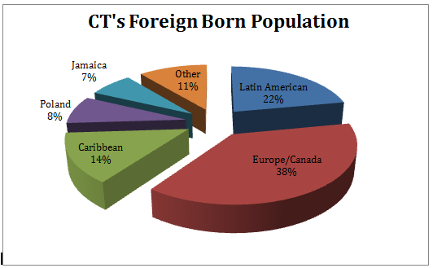
In regards to the citizenship and legal status of immigrants currently in the state of Connecticut, there are five main categories of residents. The first of these categories is naturalized citizens. This means that these types of immigrants have full access to the same benefits as the rest of the public and have the right to vote. As of 2004, fifty percent of Connecticut’s immigrants were naturalized citizens (Capps, 10). Although this proportion is decreasing because the numbers of illegal immigrants have been increasing in the past few years, this figure is still considerably higher than the nation as a whole. Therefore, naturalized immigrants in the state of Connecticut have more influence in politics than they do in the nation as a whole. The next largest group of immigrants, making up twenty-two percent of Connecticut immigrants, is the legal permanent residents. Nineteen percent are undocumented illegal aliens. Seven percent are refugees and two percent are legal temporary immigrants. These numbers were taken from the 2004 Annual Social and Economic Supplements Survey.
If we look at Connecticut’s immigration population in comparison to the United States as a whole, there are differences in the proportions of immigrants that are naturalized citizens. Nationally, one-third of immigrants are naturalized citizens. As of 2004, twenty-nine percent of the nation’s immigrants were undocumented compared to Connecticut’s twenty percent (Capps et al., 2005). A possible explanation for this could be because Connecticut is not a first destination for new incoming immigrants. Connecticut is a state where immigrants who have been in the United States for longer periods of time are going to live. Furthermore, Connecticut is a small state far away from the Mexican border, the main conduit of immigrant entry.
For those who choose to move into Connecticut, its geographic position in the United States plays a significant role in where they reside. Fairfield County, the Hartford metropolitan area and the New Haven-Waterbury area are three major areas where immigrants are clustered. Cities provide services needed by new arrivals, so it is not surprising that the three major urban areas attract the greatest numbers of immigrants. As of the 2000 U.S Census of Population and Housing, the six towns in CT (see Figure 3) that had the highest immigrant populations were Stamford with 35,000 immigrants, Bridgeport with 29,000 immigrants, Hartford with 23,000 immigrants, Danbury with 20,000 immigrants, Norwalk with 17,000 immigrants and New Haven with 14,000 immigrants (Capps).
Figure 2- Towns with the Highest Immigrant Population
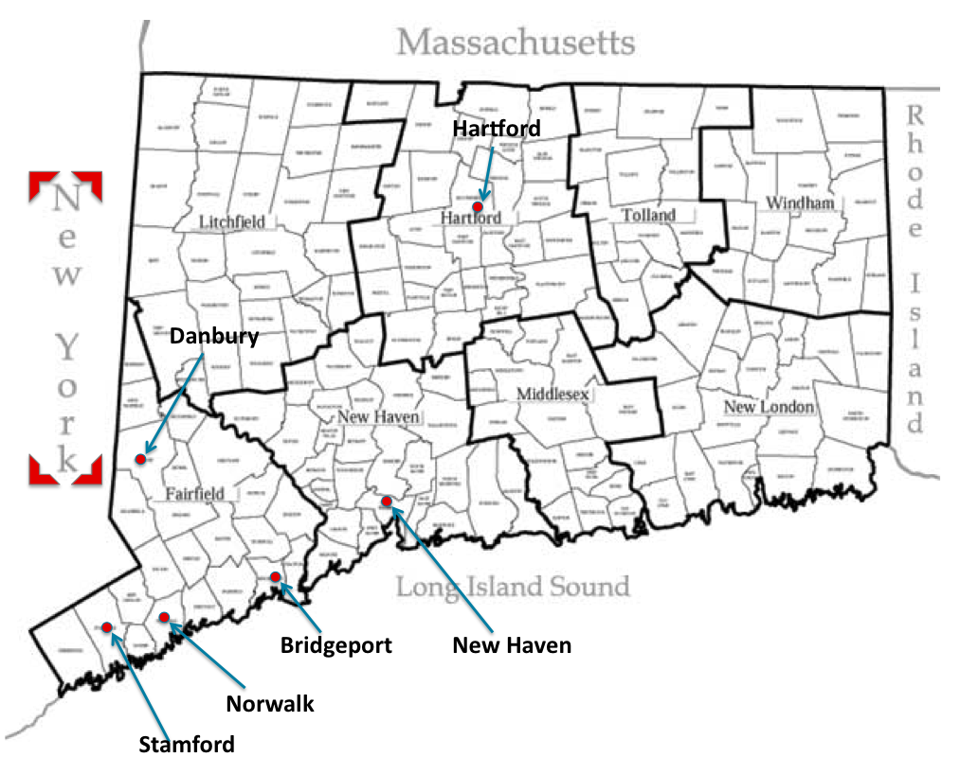

Figure 3- Immigration Distribution in CT

New Haven has become a common place for immigrants to reside, especially unauthorized ones. The city of New Haven is the first city in the nation to establish a form of ID for everyone, legal or not. The Elm City Resident card, which was initiated by Mayor DeStefano, was to provide services to the general population. It functions as a library card, a method of paying the parking meter, and the most important, a debit card. Lacking a formal ID, illegal immigrants were unable to establish their identities and open a bank account. Many kept their earnings in cash and became victims of crime. With the Elm City Resident card, this barrier is removed.
The type of education that an immigrant in Connecticut has obtained has a direct effect on the types of jobs they could potentially be hired for. A language barrier is a huge factor for an immigrant looking for work. According to previous studies, the Latin American, Caribbean and Southeast Asian immigrants in CT are the least English proficient. Of those immigrants who are 25 years of age or older, 55% of Latin American Immigrants, 24% of Caribbean immigrants and 40% of Southeast Asian immigrants currently lack high school degrees (Public Use Microdata Sample, 2000). Lacking a high school degree or higher form of education puts a severe limit on the number of possible job opportunities. As a result, jobs that require less skills to perform, that are not taken by the rest of Connecticut’s work force are the only positions available to immigrants. This can be viewed as a positive aspect for Connecticut because these immigrants are taking jobs (usually requiring physical labor) that are less desired by legal residents of the State. Asian immigrants on the contrary happen to be very well educated, even compared to United States born citizens. A majority of Asian immigrants have received four-year college degrees, making the potential positions they can hold equal to or higher than most native born residents in the state of Connecticut (Capps). Censuses taken over the past few years show that immigrants are becoming more and more educated each year, increasing the overall level of educated foreign-born individuals in Connecticut.
Due to immigrants in Connecticut becoming more educated over time, there has been a slight shift in the types of jobs being held by this segment of the Connecticut population. Most immigrants in Connecticut are occupying low-wage, low-skilled jobs and this is something that will most likely persist. Figure 4 shows the distribution of the top five categories of jobs occupied by immigrants in CT; Accommodations/Food Services, Other Services, Administrative and Support Services, Manufacturing, and Construction. Recently, the percentage of immigrants occupying higher-wage, more skill-required jobs has shown an increase. Even though the shift is minor, more immigrants are occupying professional, technical, and scientific professions.
Figure 4

In addition to the other jobs commonly held by immigrants, construction sector jobs offer an additional opportunity. Typically this involves employing immigrants at relatively low wages to do those jobs that long-term employees would prefer not to engage in, such as roofing, siding insulation and dry-walling. Illegal immigrants will work for very little money. Quoted in a release by the Connecticut Laborer’s Distict Council, Ted Duarte, an organizers for the New England Regional Council of Carpenters noted "They're easily exploitable. They'll work for $8.50 an hour. They'll work sunup to sundown, 13 to 14 hours a day, Saturday, Sunday, (sleeping) eight to a hotel room."(CLDC).The temptation to use illegal immigrants in the construction sector can be very high.
Overall, immigrants make a substantial contribution to the Connecticut economy through employment in sectors where it would be difficult to secure U.S.-born workers. The presence of substantial immigrant labor produces some weakness in the labor market for the lowest-paying jobs.
Works Cited
Bailey, Melissa. "City ID Plan Approved." New Haven Independent June 5 2007: n. pag. Web. 09 Dec 2009. <http://newhavenindependent.org/archives/2007/06/city_id_plan_ap.php>.

Capps, Randy, Karina Fortuny, Allison Cook, Everett Henderson, and Steve Zuckerman. "The Urban Institute." Immigrants in CT: Labor Market Experiences and Health Care Access. November 2005. Democracy Works, Web. 09 Dec 2009. <http://www.urban.org/UploadedPDF/311256_immigrants_in_connecticut.pdf>.
Connecticut Laborers District Council 9(Charles LeConche) 230 Charles LeConche Business Manager construction LIUNA. Construction Unions Contractors Battle over Workers. March 16, 2008.
U.S. Department of Labor. Bureau of Labor Statistics. Web. 08 Dec 2009. <www.bls.gov>.

Regional Patterns of Employment and Unemployment
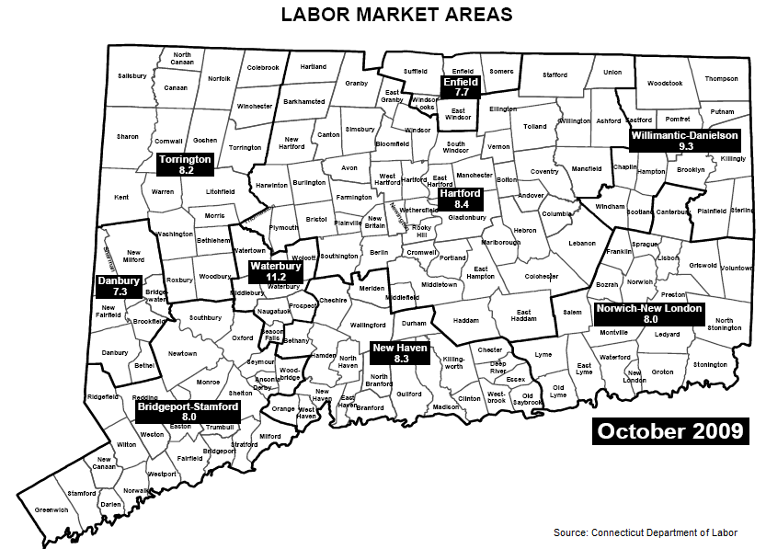
The United States officially entered a state of recession in December 2008. Connecticut’s economy followed shortly after, in March 2008. Even though Senator Lieberman said in February 2009 that Connecticut will see $2.9 billion in funding to stimulate the economy, according to statistics from October 2009 Connecticut still has an unemployment rate of 8.8%. This number can be compared to the national unemployment rate of 10.2%. The State is divided into nine labor market areas, each experiencing different employment conditions:

Graph of Unemployed vs. Employed in the nine labor markets of Connecticut

The five industries that are making the largest relative contribution to Connecticut’s real GDP (Growth Domestic Product) growth are Finance and Insurance, Manufacturing, Real estate and rental and leasing, Government, and Health Care and social assistance. Specialization within labor market areas has resulted in differing levels of labor market stress during this current downturn. Hartford, Connecticut’s state capital and second largest city, is for example known for its Finance and Insurance. It is therefore not surprising that Hartford is often called “the insurance capital of the world”. Besides this, Hartford has also an extensive list of major high-tech manufacturing firms producing products such as aircraft engines, nuclear reactors, space suits, and missile components.
Hartford’s labor market area is located in the middle of Connecticut. This area had an unemployment rate of 8.4% as of October 2009, a total of 50.516 people out of a 600.602 are unemployed. Surprisingly, Hartford hardly encounters any labor losses in its main financial activities. Looking to data from October 2008 and October 2009, the total labor force in this sector dropped five percent only. While on the other hand, construction, natural resources and mining saw the biggest change in its employment. This change was 19.7%. Manufacturing, and especially durable goods manufacturing, came on a second place with a change of 10%. ∗ The towns in the Hartford labor market area that are most affected by the economic recession are respectively Hartford itself (14.4% unemployed), New Britain (12.3% unemployed), East Hartford (10.4% unemployed), and Plymouth (9.9% unemployed).
To create employment Hartford has started several development projects. One of Hartford’s most important development projects is the 30-acre Adriaen’s Landing site on the Connecticut River. This project consists of a large convention center combined with a 22-story Marriott Hotel. Another development project the state hopes that will stimulate employment rate The Hartford 21 project, which will create a mixture of luxury apartments and commercial space housed in the City’s old civic center.
The city of Hartford had an estimated median household income of $27,654 in 2007. This is an increase compared to the $24,820 it was in 2000. This income is being earned by females in industries such as health care (18%) and finance and insurance (11%). While for males the common industries are administrative and support and waste management services (9%), construction, and accommodation and food services (both 8%). For men, the finance and insurance industry comes in at only 5th place with 6% of total employment.
In the Northwest of the State, the Torrington LMA has a labor force of only 55,374 Torrington is one of the smallest labor market areas in the state. Of the people in this labor force 4,514 are unemployed. This gives a rate of 8.2%. The towns with the highest unemployment rates in this labor market area are Torrington (10.4%), Winchester (9.6%), and Morris (7.7%). The town of Torrington is not only known for its scenic beauty, it is also known for a mix of employment opportunities in manufacturing, retail, and tourist attractions. The quarterly average wage in March 2009 in is these sectors (for the Torrington labor market area as a whole) was $12,022 for manufacturing, $6,930 for construction, and $7,340 for recreation. The top five employers in this town are the Torrington Company, the Charlotte Hungerford Hospital, O&G Industries, the Torrington Board of Education, and F.M. precision Golf Corporation. Since the city of Torrington is hit the most by today’s economic decline the Office of Economic Development in June 2009 has set up a plan to provide extensive support to current and prospective businesses of all sizes.
The basics of the plan are diversifying Torrington’s tax base, creating new employment opportunities, and strengthening the City’s role as the regional heart of Litchfield County. The Office of Economic Development wants to do this by recruiting companies to relocate to the City of Torrington. It also looks to redevelop the downtown areas of Torrington, by making it more attractive for residents and visitors. It plans on doing this by incorporating a better flow of traffic, creating mixed housing / retail spaces in the west side of Torrington, and landscaping certain areas. Since Torrington has some neighborhoods that were once the residence of employed industrial workers but now are large vacant abandoned campuses, which have environmental contaminants that are preventing redevelopment and the creation of new job opportunities, Torrington wants to revitalize these neighborhoods. Furthermore, the town of Torrington wants to foster the creation of small businesses and will continue to promote itself as the cultural and recreational hub of Northwest Connecticut in order to bring more tourists into the City and receive a larger percentage of the tourism dollars spent in Litchfield Hills. However, the minutes of September 2009 show that Torrington hasn’t really made big efforts to start this plan. In the minutes one can read that the main principle is cleaning up certain areas. It is thus questionable if this town actively tries to create more employment. A possible reason for not actively stimulating this area is that the house sales in Torrington are slowly decreasing, while the median price is slightly increasing. This means, that the housing market is stabilizing. Therefore one may think that economic stimulation can wait.
However, since Litchfield County is a very small area, with an estimated population in 2008 of 187,745 compared to about 3,500,000 of the whole state, it might not have enough money for economic redevelopment. According to the U.S. Census Bureau Litchfield County has a small number of building permits (261) in 2008, as well as a small amount of federal spending ($1,081,351). An example of this spending can be found at the Winsted Republican website. The area of Winchester is now receiving funding of approximately $55,000. However, what can one do with this money? It will not be enough to generate effective development to stimulate job growth.
Torrington’s median household income in 2007 was $50,863. The most common occupations in this area for males are other production occupations including supervisors (7%) and metal and plastic workers (7%). For females the most common occupations are other office and administrative support workers including supervisors (6%) and secretaries and administrative assistants (6%).
Located on the north side of Connecticut is the smallest labor market area of the Connecticut state: Enfield. Enfield has a labor market force of 50,242. Out of this number 3,893 are unemployed, which leads to an unemployment rate of 7.7%. Thereby it is the second lowest from Connecticut’s nine labor markets. One of the biggest industries in Enfield labor market area is manufacturing, especially transportation equipment manufacturing. The average quarterly wage in March 2009 for this sector was $24,228. Compared to the $22,761 it was in the fourth quarter of 2008, it shows that the wages in this part of the industry are growing as well.
The towns that are affected most by the economic downturn in this last area are East Windsor (8.3% unemployed), Windsor Locks (8.2%), and Enfield (8.0% unemployed). All of these towns are located near Bradley International Airport and therefore a lot of industries have links with it. For example Windsor Locks, the home of the airport, serves as a major northeastern distribution center. It is home of several regional companies, such as American Honda, Federal Express, and UPS facilities. Also located there are aerospace products (Hamilton Sundstrand) and many paper goods (Ahlstrom-Dexter, LLC).
The city of Enfield is best known for housing the U.S. headquarters of Lego –the Danish plastic building toy – and Hallmark Cards. Both companies have created a lot of employment opportunities. However, while the Lego Company is the biggest employer in this town, it announced in June 2006 it was to begin outsourcing jobs in Mexico. This meant that over 290 employees will be laid off. Enfield has several stimulus projects. One of them is a transport project. The basic of this project is the repair of a bridge on Rt. 5 in Enfield. While this project has been planned for a long time, stimulus money wasn’t being given until late June 2009. Because of this postponement, Enfield, like the rest of Connecticut, saw a lot of losses in the construction sector. Another project that seems likely to receive funding is the building of a transit center. Enfield will receive about $1 million to fund phase one of this project. This will create not only employment for the construction of this center; it should also lead to more employment when the transit center is done.
Enfield’s median household income in 2007 was $63,568. This income is being earned by females in the industries of Health care (15%), Finance and insurance (14%), and Educational services (11%). While for males the most common industries are Construction (9%), Finance and insurance (8%), and Transportation equipment (7%).
Waterbury is an older manufacturing city, with a population of 103,651 people, located in central Connecticut. It has the highest unemployment rate, 11.2 percent, out of Connecticut’s nine labor market areas. It has 92,079 employed citizens. Waterbury is mainly a manufacturing city, best known for its past specialization in brassware. However, the city is trying to diversify its industrial and service bases. Businesses that include chemical research and banking are moving to Waterbury.
Waterbury’s median household income is$ 39,957, while the average for the state of Connecticut is $65,967. The most common jobs for males in the city are in metal and plastic works as well as in other production industries. The least common jobs for males in Waterbury are in sales and truck drivers. The most abundant jobs for women in the city are in nursing, psychiatric, and home health services.
The labor market area of Connecticut’s most populated city, Bridgeport, has an unemployment rate of eight percent as of October 2009 and 442,076 people are employed in the LMA. Bridgeport was until recently a predominately manufacturing city. Industries in the city have begun, however, to shift with the current economic state of our country. Bridgeport is now implementing new projects on brown- fields and in service industries to increase employment. Harbor Yard has acted as a growth pole and employs Bridgeport citizens. Health and financial services have also sprouted in the city to help employment. Bridgeport has a deep-water port and near many major transportation hubs, therefore wholesale and other trades benefit at this location.
Bridgeport’s largest employer is the People’s Bank with over 3,000 employees. The average household income in Bridgeport is about $44,216. The most common jobs for males are building and grounds cleaning and maintenance occupations, and the least common jobs for males are in sales. The most popular jobs for woman in Bridgeport are the same as those in Waterbury, and are in health services, nursing, and psychiatric. The least abundant jobs for woman are in customer service representatives.
The Danbury LMA has an unemployment rate of 7.3 percent and 85,727 citizens employed within the city. The average household income in Danbury is $59,346. The three main industries in Danbury are manufacturing, retail, and trade. The Danbury Fair Mall supplies much of this area’s economic growth, and the retail industry supplies many jobs to the Danbury area. The area also is a hub for many other services, including insurance, banking, law, and government.
The largest employers for this labor market area are the Danbury Hospital with 3,000 employees and Cendant Mobility with 2,200 employees. The most common job for males are in Building and grounds cleaning and maintenance occupations, like in Bridgeport, and the least common jobs for males are in the retail industry. The most abundant jobs for woman in Danbury are in secretaries and administrative work, and the least common jobs for woman are as registered nurses.
In the Willimantic-Danielson labor market area, a 9.3 percent unemployment rate rests between the Connecticut and National averages. Established in the area, the former production facility of the American Thread Company has been repurposed as office space, symbolizing the slow transition from textiles to service. Data from the Connecticut Department of Labor indicates that Willimantic is bleeding jobs from the dying manufacturing sector while not recouping the losses in other areas. With 2 of the 5 fastest growing jobs in the state connected to information technology, Willimantic lags behind with only 162 jobs (.004%) belonging to the telecommunications sector. Whereas manufacturing jobs account for only 10% of the state labor force, Willimantic depends on 15% output from localized production. This disparity in economic composition has left the area in a significantly worse position than its geographic counterparts inside the state.
The five largest industries in Willimantic-Danielson are Government, Healthcare, Manufacturing, Retail and Food Service. Atypical for the region is a dearth of employment in Educational Services. Eastern Connecticut State University – Willimantic’s largest school – employs only four employees for every hundred employed by UConn, the state’s flagship school and a product of the Hartford labor market area . Of its five largest sectors, Healthcare is closest to booming. State projections have the Heath Services industry expanding by 11% through the year 2016. Government employment is projected to be static, while retail (5%) and food service (10%) are expected to see more modest gains in employment. Manufacturing will experience job contraction just southward of four percent through 2016. Ultimately, Willimantic’s future will depend firstly on a realignment of top industries to better fit the modern economic landscape.
In the Connecticut portion of the Norwich-New London labor market area, unemployment is relatively low at 7.8%. The strong showing in the Norwich area is supported by the presence of the United States Military and the Mohegan Sun and Foxwoods casinos, which employ approximately 40,000 people collectively and contribute substantial spillover effects to the area. Non-farm employment has contracted by 3.3% in this region over the past year. According to data from the Labor Department, employees in the leisure and accommodation sector are earning average quarterly wages below $5,000 – indicating a lower quality of life for what amounts to a large employment base. In 2007, Foxwoods’ table dealers voted 60-40 in favor of unionization, thus earning collective bargaining rights for over 3,000 workers. Foxwoods responded in late 2008 by firing 700 of these workers before an agreement could be reached. Casino activity remains strong, in spite of declining numbers. Tourism revenues dropped 8 percent from fiscal year ’08 to ’09, inducing a concurrent drop in state slot remittances. By law, both casinos are mandated to turn over 25% of slot revenues to the state.
Consistent with other parts of the state, Norwich-New London’s 20,100 jobs in education and health services have grown by one percent over the last year. Federal jobs in the area have grown by 3.7%, while state and local municipalities have trimmed down by 5.5%. States, required by law to have a balanced budget, are never granted the same fiscal latitude as their federal counterparts.

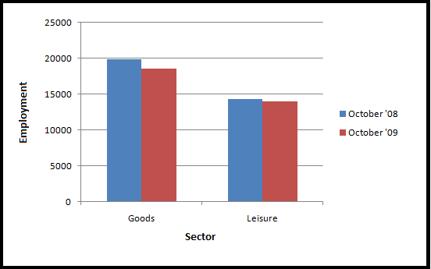
Graph Contrasting Goods and Leisure Trends in Norwich-New London

Perhaps the most important economic force in the area is not casino gaming, but national defense. Home to both the Groton Submarine Base and United States Coast Guard Academy, the Norwich labor market area depends on armed forces employment. Whereas armed forces employment is nearly absent from the labor force in most Connecticut towns, it plays a significant role in this area – accounting for about 20% of workers from the town of Groton. In terms of impact on employment for residents of Norwich-New London, no development was greater than the 2005 announcement by the U.S. Department of Defense that it would closing the base as part of a national realignment program. Under this initiative, 100% of the drop in employment would be derived from the state’s southeastern labor market areas. Economist Douglas Hall of UConn estimates that the sub base, grouped with employment from the civilian-staffed Electric Boat Company, accounts for $3.3 billion, or 1.8%, of Connecticut’s Gross State Product. The presence of the base cannot be overestimated, as Hall believes it is directly or indirectly responsible for 31,500 jobs inside the state. After lobbying from both CT Governor Jodi Rell and State Representative Rob Simmons, the base was stricken from the closure list in late 2005. The U.S. Coast Guard Academy, one of five main military academies in the country, has just under 1000 cadets and 120 faculty members.∗
New Haven, Connecticut’s third largest LMA, has an 8.3% unemployment rate. Non-farm employment has declined by 1.8% over the past year, accompanied by upward shifts in the size of the labor market as wealth erosion occurs amongst discouraged workers. The largest employer in New Haven is unequivocally Yale University, including Yale-New Haven Psychiatric and Yale School of Medicine. As a city, New Haven is notable for the amount of wealth that leaves city bounds when the work day is over. Those who work in New Haven are earning an average annual wage of $47,796, versus just $16,393 for those who reside in the historic city. The city itself is also home to Southern Connecticut State University, a state subsidized college employing over 1,000 people. After education, healthcare and health services is New Haven’s dominant sector. Of the 15 top employers in this labor market, 11 are a part of the healthcare industry. Commanding a plurality of New Haven’s workers, healthcare is expected to grow over the next half decade and will leave the area in sound fiscal shape. Both the state Department of Veterans Affairs and the state Veterans Hospital are located in West Haven, providing gross employment over 2,000 to the region. The VA is also part of the 2008 Recovery and Reinvestment Act, meaning dollars earmarked for Veterans will arrive and be processed by the state branch.
According to the Connecticut Economic Digest, nearly every sector in the New Haven labor market area has lost jobs from October 2008 to October 2009. Wholesale trade, however, has expanded by 0.8%. A large share of this growth is attributed to Bozzutos, Inc.; a grocery wholesaler located in Cheshire. Bozzuto’s is a full-line grocery distribution company supplying to IGA stores in New York, New Jersey, Pennsylvania and all of New England. Employing over 3,200 in its Chesire production facility, Bozzuto’s has recently undertaken efforts to expand into part of a North Haven facility formerly controlled by Stop & Shop. Bozzuto’s is an excellent regional example of a firm that has been able to buck trends by becoming an important central hub – essentially a bridge between the grocery industries on both sides of the Northeastern United States.
Since New Haven’s unemployment rate of 8.3% is in the middle of Connecticut’s other labor market areas, it makes an excellent microcosm of state successes and failures. Like the rest of Connecticut, New Haven is buoyed by very strong educational and health services sectors. Manufacturing represents 10.4% of employment in the LMA – a figure that has been declining. New Haven does have linkages to the financial services sector and New York, but not to the same extent as Bridgeport/Stamford.
As the above stated facts show, Connecticut does suffer from the economic downturn in today’s world. The unemployment rate in Connecticut’s nine labor market areas ranges from the lowest of 7.3% in Danbury to the highest of 11.2% in Waterbury. However, Connecticut’s average unemployment rate of 8.8% is still lower the national unemployment rate of 10.2%.
The table below sums up the employment of the whole state of Connecticut in the several industries. It shows that Connecticut’s employment is especially dependent on Educational and Health Services, as described before. Due to the increase in the average age and the plans of the government in the field of health care and health insurance a stable growth may be expected there.

Industry | Employed
Goods Producing Industries | 225,900
Construction, Mining | 55,200
Manufacturing | 170,700
Trade, Transportation, Utilities | 292,800
Information | 34,500
Financial Activities | 137,700
Professional and Business Services | 188,900
Educational and Health Services | 303,200
Leisure and Hospitality | 139,900
Other Services | 61,500
Government | 251,300
Table Connecticut Employment (as of October 2009)

State Initiatives – “Growth Poles”
Growth poles may be defined as large, deliberate investments that aim to cause spillovers into surrounding regions. This type of development promotes land usage and infrastructure in generating regional growth. Perhaps the most crucial aspect of growth poles is the need for linkages. Interaction between the development and its surrounding areas is essential to producing spillover effects. When implemented properly, growth poles yield a number of benefits, ranging from economic growth to the creation of jobs. Development projects can push back against decline and attract external dollars to an urban area. Adriaen’s Landing, for example, was targeted towards helping revitalize the city of Hartford. This development continues to accomplish the ideal goals of a growth pole, increasing economic growth and attracting people to the area. Bridgeport’s Steel Point Harbor is a development project currently in the process of being planned and implemented. Despite its development in the midst of an economic recession, Steel Point shows great potential for improving segments of the economy of the city of Bridgeport and bringing in additional revenues.
Adriaen’s Landing: Hartford, CT
Adriaen’s Landing is a deliberate growth pole made up of thirty-three acres in the city of Hartford that has transformed this once depressed area into a multi-faceted destination of stores, convention centers, apartments and cultural attractions, helping transform downtown Hartford. The project was designed to change the landscape of the downtown Hartford on a scale that hasn't been seen since the construction of the Civic Center in the mid-1970s and Constitution Plaza in the early 1960s.
In 1995, The Phoenix Company began preliminary designs for a project to redevelop a plot of land in downtown eastern Hartford. Supported and assisted by The Travelers Group, CTG Resources, Inc., the City of Hartford, the State of Connecticut, and numerous regional organizations, the study grew to include over 30-acres of land and associated air rights in a publicly funded mixed-use complex.
As the development began attracting new interest in downtown Hartford, Federal, State and Local officials became intrigued and formed The Capital City Economic Development Authority and passed Connecticut Public Act 98-179 which provided further funding for projects in downtown Hartford, including the Adriaen's Landing project. The Capital City Economic Development Authority became a quasi-public authority charged with directing certain state-supported economic developments in and around Connecticut's capital city.
As development of the project began to get underway, the State proposed a team consisting of the Capital City Economic Development Authority (CCEDA), the State of Connecticut Office of Policy and Management (OPM), and the Waterford Group. The team worked together to revise ideas and situations for the development of the project under the auspices of Public Act 99-241, which was enacted to alter the initial development legislation, and on May 31, 2001, Governor John G. Rowland, Mayor Michael P. Peters, and Waterford Development CEO Len Wolman broke ground at Adriaen's Landing.
The centerpiece of Adriaen’s Landing is The Connecticut Convention Center which rests on the edge of downtown Hartford. The building cost $271 million, and encompasses more than 200,000 square feet of exhibition and meeting space overlooking the Connecticut River where interstates 84 and 91 converge. The ability to modify the existing infrastructure of the interstates reinforces the success of this development because it allows for straightforward transportation from highway to destination. In addition to the convenient access from highways, the Convention Center is also connected to The Marriott Hartford Downtown, which is the first new Hartford hotel development in more than 20 years. These two buildings are able to create employment opportunities for local residents in addition to attracting large numbers of visitors from neighboring states. The convention center allows for large business meetings and trade shows, so it attracts foreign companies to the area to work during the day and stay overnight at the Marriott Hotel.
In June 2009, the Connecticut Science Center was opened to the public after years of extensive planning for this education economic development initiative at Adriaen’s Landing. This $150 million science center has become a regional destination attraction and is expected to draw up to 400,000 visitors a year. The Science Center is located next to the Connecticut Convention Center and is within walking distance of neighborhoods and the entertainment/retail district of Front Street. In addition to its convenience to other popular attractions, the center provides the potential for innovation in Adriaen’s Landing as well as the surrounding periphery by providing information on advancements in the current technological world. The Connecticut Science Center is a vital new resource for parents, students, and the educational system because, as the competition for scientific discovery and technology leadership increases, the center has the ability to teach and provide the most up to date information for individuals of all ages. The Science Center attracts families and schools from around the state to its 140,000 square feet of exhibition space, laboratories and a 3-dimensional theater to help facilitate new learning and talent. The science center creates valuable linkages that are both backward and forward because it is able to teach young generations about science and information, while also doing research with experts to further scientific developments
The final development project within Adriaen's Landing was the nine-acre residential, entertainment, and retail district known as Front Street. This district was located directly across from the Convention Center and was designed to bring back the once bustling riverfront neighborhood by enhancing the visitor experience with a variety of amenities. Front Street provided local residents with a destination designed to facilitate evening entertainment and leisure. It was also convenient for visitors because after attending a trade show, business people could then walk across the street to get dinner and entertainment with the beautiful views of the water. As the district became increasingly well known, more businesses wanted to locate within the area because of the increase in propulsive firms and presence of self-sustaining growth.
These attractions within Adriaen’s Landing have been very successful in drawing people to the area and it has encouraged a rise in growth and employment. In July 2008, an economic and fiscal impact study of Adriaen’s Landing projected that the project would create an average of 1,852 jobs and $7.8 million in net new tax revenue annually for the state. The study, conducted by the Department of Economic and Community Development, also concludes that the city will realize an annual average of $26,453,876 in net new local revenue as a result of Adriaen’s Landing’s construction and operations. With the help of Adriaen’s Landing, this section of Hartford has been transformed into an multi-faceted, waterfront destination for the first time in decades. The development has created new signs of confidence in the city’s future and has expanded Hartford’s infrastructure into the periphery of surrounding cities and towns within the area.
Steel Point Harbor: Bridgeport, CT
The current Steel Point Harbor project is a major attempt to redevelop the harbor area of Bridgeport and push back against the city’s decline. The region has great potential for growth, yet is associated with a number of failed attempts to stimulate the city’s economy. The city contains many brownfields, abandoned, industrial areas, left over from the city’s former role as a manufacturing center. The Steel Point Harbor project aims to redevelop a peninsula in Bridgeport, hopefully leading to the revitalization of a city. Ideally, the area will serve as a center for growth, resulting in a number of spillovers into the city and surrounding areas.
The land being used in this development project is currently considered a brownfield, once home to a steel plant and electrical substation. A substantial amount of cleanup was required due to a number of pollution problems. This served as a preliminary benefit for both the developers and the community in terms of upgrading the environmental health of the city. Steel Point Harbor, spanning fifty-two acres, will bring $1.5 billion into the city once completed. The neighborhood will include an array of new developments, including restaurants, shopping centers, entertainment facilities, residential and office buildings, and a yacht club. The crucial element in this project is the ability of developers to integrate Steel Point Harbor into the city as a whole. A successful integration will provide linkages to surrounding areas, benefiting residents and visitors. The construction of office buildings will attract a unique genre of people to an area that has been abandoned for a significant period of time. Businesses will bring in people on a daily basis, resulting in constant economic interaction. For example, people working in Steel Point will take advantage of restaurant and entertainment facilities. Many will utilize public transportation, increasing the demand for transportation services. The ability for companies to conduct business in the area will bring in visitors and investors.
The components of the project have changed significantly since the planning first began. Due to the current economic downturn, the original project was downsized and will be constructed in four phases. This will allow RCI Group to purchase the city-owned property in pieces, rather than as a whole. The benefit of purchasing the land in parts is that financing will be easier since lending has become increasingly difficult. The first phase will involve constructing the marina and waterfront, in addition to approximately 140,000 square feet of retail space. Housing developments were originally meant to make up a big part of the project; however, this component will not begin construction until the market begins to improve. Originally, almost 4,000 condominiums and apartments were to be built. The most recent, scaled-down version has reduced that figure to 1,200. While development projects are investments, Steel Point Harbor’s adjustments prove that the current state of the economy plays a huge role in a project’s feasibility.
In comparison to other projects in Bridgeport, Steelpoint’s primary goal seems to be creating a public area that will keep people in the city. By revamping the city and developing commercial facilities, the city will be able to retain its inhabitants as well as attract visitors. This will create strong linkages between Steel Point and the surrounding areas of Bridgeport since there will be a steady influx of people navigating between the regions. Steel Point is in a prime location. The land has direct access to I-95, and it is within walking distance of downtown, the train station and ferry. A unique element of this development is its loop system for streetcars, which will connect to the Bridgeport Intermodal Transit Hub.
Another major point concerning the massive development is the obvious creation of jobs. In a time where unemployment rates have reached record highs, this may be the most beneficial component in the short-term. It is estimated that the construction of Steel Point will create over 16,000 construction jobs. In addition, there will be about 9,000 permanent jobs after it is completed. Typical jobs will most likely include office and administrative workers, maintenance and grounds cleaning employees, accommodation and food service workers, and finance and insurance employees. Furthermore, the developers estimate about $25 million dollars to be generated in annual tax revenue. This growing tax base will help pay off the project in the long run.
The project’s primary objective is focused around the community. Planners hope to ensue pride in the city of Bridgeport and create a development that will benefit all those exposed to it. Bridgeport’s image may improve, removing the stigma often associated with the city. Residents and visitors will have access to shopping, leisure, and entertainment facilities. However, certain community members have spoken out against the housing component of the plan. Many have expressed outrage over the minimal communication about their desires and demands, namely the lack of enough affordable housing available. The developers are using the regional median income, which is much higher than Bridgeport’s median income, resulting in fewer affordable units being built. Some middle ground must be found on this issue in order to have the community’s support in the largest development project to date.
Steel Point Harbor proves to be the best attempt in history to refurbish Bridgeport’s image, community, and economy. Developers hope that this will serve as a catalyst that will inevitably lead to future investments, projects, and economic growth. It will most likely become a necessary growth pole that will bring in a large number of people and external dollars. This economic rise will result in spillovers to surrounding cities, benefiting the people and economy of Bridgeport. Lastly, the number of employment opportunities will increase drastically at a time when it is needed the most.
Growth poles are able to transform depressed or developing areas into a successful geographic entity that recreates city structure and encourages growth in population. Through the use of linkages, innovation, and the potential for self-sustaining growth, areas such as Adriaen’s Landing and Steel Point have the ability to transform troubled urban zones into prosperous area of economic activity.
Industrial Specialization and Job Creation

Traditionally, Connecticut’s economy has stood on the following legs: financial services, insurance, private and public institutions of higher learning (particularly the University of Connecticut and its branch campuses), health care, GE (their corporate headquarters is in Fairfield), Pratt and Whitney, and Sikorsky. It is clear that Connecticut relies on the transportation and defense industries, as well as sectors whose strengths and weaknesses are correlated to business cycle fluctuations. Connecticut has been trying to establish new sectors to supplement these key businesses. Some strategies Connecticut has not considered include the creation of technology corridors and the growth of export-intensive sectors. After the filming of “Revolutionary Road” in Connecticut, the state has been dubbed “movie-making East,” thus making it the potential home of a movie-making corridor; this would include subsidies, studios, and many jobs for the state of Connecticut.

Technology corridors, which are a type of Enterprise Zones, have not been used by Connecticut. They are meant to link existing strengths with planned future development. Technology corridors include studies and projects in bio-tech, bio-science, protein sciences, and computers. An example of a very successful technology corridor is Massachusetts is Route 128. The highway was built in the late 1920s, and it gained significance after the emergence of the high-tech industry in the 1970s, and 1980s. By including technology planning with economic planning, states are “mounting full-blown strategic campaigns to refashion their local economies in a high-tech mode” in order to achieve economic growth (Muniak). Technology corridor initiatives emerged in the 1990s as “a new kind of grassroots industrial policy, differentiated in its target from earlier urban economic development approaches” (Muniak). Technology corridors can be important development tools, and there are many notable ones across the country. The city of Harrisburg, Pennsylvania offered low-interest loans, tax credits, and other developmental programs. Harrisburg, Pennsylvania and Massachusetts Route 128 in Boston are just two examples of how cities can “seek to emulate the 'boom' experiences of the nation's vanguard centers of high technology industry” (Muniak).

Connecticut has also focused in on the creation growth clusters. Growth clusters enable the state to push jobs towards certain sectors or industries. The aerospace industry, an old economic leg, is being promoted as a growth cluster, but without the military label and component attached to it. Seeing as how Connecticut is home to the NASDAQ, it is also promoting jobs in software and information technology to create economic growth. Given the spill-overs from the recent financial crisis, the state faces the tough task of propping up firms in the financial services and insurance sectors that have suffered set-backs in the last year and a half or so. Bio-sciences and other research corridors have been proposed as growth clusters that will look to establish new legs for the state to stand on.

Moving forward, Connecticut would benefit from a focus on export-intensive sectors like air and transportation equipment, computers, and machinery. These sectors make up a majority of the state’s exports, but these sectors account for only roughly 5 percent of Connecticut’s GDP. Connecticut must also utilize its wealth more effectively. The state must advertise tourism, as well as encourage graduates of schools like the University of Connecticut to stay in-state, and subsequently boost the state’s commerce and capital.

Works Cited

Connecticut Recovery Initiative
<http://www.recovery.ct.gov/recovery/site/default.asp>

Muniak, Dennis C. "Economic development, national high technology policy and America's cities." Regional Studies 28.8 (1994): 803+. Web. 14 Dec. 2009. <http://find.galegroup.com/gtx/start.do?prodId=EAIM&userGroupName=a04fu>.

∗ These numbers are not seasonally adjusted.
∗ It should be noted that the Norwich-New London LMA also encompasses several towns in the state of Rhode Island, which were excluded from this report.
"Adriaen's Landing." Hartford History. Web. 4 Dec. 2009. <http://www.hartfordhistory.net/adriaen.html>.
"Adriaen's Landing." Hartford: Happening as we Speak. Greater Hartford Convention & Visitors Bureau. Web. 18 Nov. 2009.
Fleury, Matt. "Adriaen's Landing Project Breaks Ground." Capital City Economics Development Authority. Hartford Government, 31 May 2001. Web. 24 Nov. 2009.
"Adriaen's Landing." Capital City Economics Development Authority. CCEDA. Web. 2 Dec. 2009. <http://www.cceda.net/projects/adriaens_landing.html>.
"Adriaen's Landing." Hartford: Happening as we Speak. Greater Hartford Convention & Visitors Bureau. Web. 18 Nov. 2009.
"Adriaen's Landing." Hartford: Happening as we Speak. Greater Hartford Convention & Visitors Bureau.
Cooper, Chris. "Governor Rell Announces $5.5 Million for Hartford’s Adriaen’s Landing." State of Connecticut. Department of Economic & Community Development, 25 July 2008. Web. 4 Dec. 2009. <http://www.ct.gov/ecd/cwp/view.asp?A=1104&Q=420198>.
“Steelpoint: A Step Forward.” New York Times. 11/04/2007. New York Times, Web. 7 Oct 2009. <http://www.nytimes.com/2007/11/04/opinion/nyregionopinions/CT-steelpoint.html>
Steelpoint Harbor. Web. 7 Oct 2009. <http://www.steelpointharbor.com>
Gosselin, Kenneth. “Bridgeport Steel Point Harbor Project Now Planned In Phases.” Courant. 09/03/2009. Hartford Courant, Web. 7 Oct 2009. <http://www.courant.com/business/hc-steelpoint-agreement-is-reached.html>
Steelpoint Harbor. Web. 7 Oct 2009. <http://www.steelpointharbor.com>
Steelpoint Harbor. Web. 7 Oct 2009. <http://www.steelpointharbor.com>
“Steelpoint: A Step Forward.” New York Times. 11/04/2007. New York Times, Web. 7 Oct 2009. <http://www.nytimes.com/2007/11/04/opinion/nyregionopinions/CT-steelpoint.html>

